Inflation, Information, and Delayed Repricing

Inflacija, informacije i odgođene promjene cijena
Luka Šikić · Petra Palić Catholic University of Croatia, Department of Communication Studies, Zagreb Corresponding author: luka.sikic@unicath.hr
Category: original scientific paper (izvorni znanstveni rad) JEL classification: E31 · D40 · L11 · D91 · C55 · Z12

Abstract
Price data reveal adjustment but rarely whether a price setter had already noticed the shock. We use dated media coverage to study this distinction in Croatia’s religious sector, for which no official fee index exists. The new official DigiKat database contains 413,985 religion-salient posts. Coding identifies 475 domestic religion–inflation connections. Direct sector speech about its own costs or revenues appears in 83 posts and peaks in October 2022. Repricing coverage peaks in June 2024, 20 months later, when the harmonised price level was 25.7 per cent above June 2021. Four named bodies appear first in own-position speech and later in repricing coverage; three lags exceed one year. The evidence rejects neither inattention nor menu costs, but shows that information about the relevant economic object was publicly available well before adjustment coverage became concentrated.
Keywords: price rigidity; rational inattention; fairness; nonprofit pricing; media as data; Croatia

Sažetak
Podaci o cijenama otkrivaju prilagodbu, ali rijetko pokazuju je li određivač cijene već uočio šok. Datirano medijsko izvještavanje koristimo za analizu te razlike u hrvatskom vjerskom sektoru, za koji ne postoji službeni indeks naknada. Nova službena baza DigiKat sadrži 413.985 religijski relevantnih objava. Kodiranjem je utvrđeno 475 domaćih poveznica religije i inflacije. Izravan govor sektora o vlastitim troškovima ili prihodima pojavljuje se u 83 objave i doseže vrhunac u listopadu 2022. Izvještavanje o promjenama cijena doseže vrhunac 20 mjeseci poslije, u lipnju 2024., kada je harmonizirana razina cijena bila 25,7 posto viša nego u lipnju 2021. Četiri imenovana tijela najprije govore o vlastitom položaju, a poslije se pojavljuju u izvještajima o promjeni cijena; tri su odmaka dulja od godine dana.
Ključne riječi: rigidnost cijena; racionalna nepažnja; pravednost; cijene neprofitnih organizacija; mediji kao podatak; Hrvatska

1. Introduction
An unchanged price is compatible with different economic mechanisms. A seller may not have acquired or processed new information. The seller may instead understand that costs have risen but postpone action because adjustment is administratively costly, organisationally slow or difficult to justify to customers. Observed prices alone do not distinguish these cases.
This paper uses public information to narrow that ambiguity. It studies the Croatian religious sector during the inflation shock that began in 2021 and surrounded the euro changeover in January 2023. Religious organisations provide services such as funerals, marriages, masses for intentions, pilgrimages and charitable assistance. Customary fees or expected contributions exist, yet no official index records when these amounts change. Dated media reports record a different part of the process: statements about household hardship, statements about institutional costs and revenues, and reports of repricing.
The empirical design treats media coverage as an event register, not as a substitute price index. Three questions organise the analysis. First, does cost-of-living coverage inside religion-salient media content move with measured inflation? Second, did sector actors discuss their own economic position before repricing coverage became concentrated? Third, can the same named institutional bodies be observed in both kinds of event?
The new official DigiKat database changes the empirical base materially. It applies one religion-relevance rule to both collection eras and reduces the earlier broad accumulator to 413,985 posts. Re-running the complete selector yields 761 coding candidates and a measured domestic set of 475 posts. The smaller and more precise database weakens the early correlation between media attention and headline HICP to 0.48, but it does not alter the central sequence. Direct own-position speech peaks in October 2022. Repricing coverage peaks in June 2024, 20 months later. Four named bodies appear in both own-position speech and later repricing coverage, and three of those lags exceed one year.
The contribution is deliberately bounded. Public speech cannot reveal private cognition, and a report of repricing need not coincide with the formal decision date. The evidence nevertheless shows that information about the sector’s own costs and revenues existed in public sector speech well before repricing reports became concentrated. Pure inattention to the relevant object is therefore insufficient as an aggregate account. Fairness constraints, dispersed governance and adjustment costs remain observationally compatible explanations.

2. Information, adjustment and mission-based pricing

2.1 Inattention and sticky information
Sticky-information models allow plans to remain internally coherent but based on old information because agents update intermittently (Mankiw & Reis, 2002; Reis, 2006). Rational-inattention models treat attention as scarce and predict that organisations allocate it to signals with the highest expected value (Sims, 2003; Maćkowiak & Wiederholt, 2009). These mechanisms make the object of attention important. Public concern about household budgets does not establish that a parish, diocese or religious order has processed its own energy bill, wage costs or revenue shortfall.
The present data separate those objects. Household-hardship speech records the sector discussing burdens borne by families, pensioners or the poor. Own-position speech records direct sector statements about its heating, wages, maintenance, repairs, collections, fees, budgets or other finances. Only the second category is close to the state variable relevant for the sector’s own repricing.
This does not mean that public statements reproduce private beliefs. Statements may be strategic, incomplete or delegated to actors who do not hold price-setting authority. They are still useful because they place relevant information in the organisation’s public communication at a known date.

2.2 Adjustment costs and fairness
Menu-cost models begin after information has been acquired. A seller changes price only when the expected gain exceeds a fixed adjustment cost. Larger shocks move more sellers across their thresholds and therefore tend to increase adjustment frequency (Golosov & Lucas, 2007). Micro-price evidence documents substantial heterogeneity across sectors and inflation regimes (Bils & Klenow, 2004; Dhyne et al., 2006; Gagnon, 2009; Nakamura & Steinsson, 2008; Alvarez et al., 2019).
Fairness adds a relational constraint. Customers evaluate whether a price increase preserves a reference transaction and whether the seller is protecting a reference return or exploiting circumstances (Kahneman et al., 1986). Surveys of firms similarly indicate that information limits, administrative frictions and concern about customer reaction can coexist (Blinder et al., 1998; Coibion et al., 2018).
For a mission-based organisation, highly visible inflation may strengthen rather than relax the reputational cost of repricing. Users may accept an increase justified by costs but resist one that appears inconsistent with the organisation’s public concern for households. Waiting until salience falls can then be privately rational even as the accumulated relative-price gap grows. Annual budgeting, hierarchical consultation and formal approval could generate the same timing. The analysis can identify a sequence consistent with these mechanisms but cannot separate their causal effects.

2.3 Why the religious sector is informative
Nonprofit organisations cannot distribute residual earnings to owners and often combine revenue, cross-subsidy and mission in one objective (Hansmann, 1980; Steinberg, 2006). Nonprofit status does not eliminate asymmetric or sluggish pricing (Jackson, 2014), but it can weaken the direct mapping from cost to price.
Religious services sharpen these features. A mass intention, funeral or marriage is not experienced as an ordinary market transaction even when a customary fee exists. Close substitutes may be absent, automatic indexation is unusual, and authority is dispersed among parishes, dioceses, religious orders, the bishops’ conference and the Vatican. Information can be available at one level without producing action at another.
Catholic social teaching also places household hardship and distributive fairness inside the sector’s stated public mission. We do not evaluate doctrine. We use this institutional setting to distinguish speech about others’ hardship from speech about the organisation’s own economic position, extending work on religious organisations as clubs and welfare providers to their role as price setters (Iannaccone, 1998; Kallunki & Zrinščak, 2021; Stubbs & Zrinščak, 2009; van Kersbergen & Manow, 2009).

3. Data and methods

3.1 The new official database
The official DigiKat corpus contains 413 985 religion-salient Croatian digital media posts published from 2021-01 through 2026-06. It includes web portals, social platforms and forums, and both confessional and secular publishers. The database is derived from a larger monitoring accumulator, but every retained post now passes the same inclusion rule: a version-four religious vocabulary is evaluated within the first 3,000 characters, requiring at least one decisive and two total matches, followed by a second-pass ensemble score of at least 0.70.
The collection instrument still changes over time. The monitoring stream covers the earlier period; a filter-based backfill supplies the later period. Both now use identical relevance criteria, but their capture processes are not identical. February through May 2024 contain no text in the vendor feed, January and July 2024 are partial months, and the two streams overlap only narrowly. Raw counts are therefore not treated as one uninterrupted exposure series. Temporal quantities are estimated within stream, while event dates are interpreted descriptively.
The target population is religion-salient digital content, not all Croatian media and not Catholic outlets alone. Results describe what becomes visible when religion and economic hardship meet in this monitored public record.

3.2 Cost-of-living selection and substantive connection
A fixed Croatian vocabulary identifies literal inflation, rising prices, cost-of-living pressure and purchasing power. The bare word for price is excluded because devotional texts frequently use it metaphorically. A separate guard removes expressions such as “inflation of words” while preserving a post that also discusses real prices.
This rule finds 1 486 cost-of-living posts, 0.36 per cent of the official corpus. A proximity selector then requires religious language within 220 characters of a cost-of-living expression. It masks documented homonyms before measuring the distance. The procedure returns 761 candidates.
Candidate status is not substantive evidence. Coders decide whether the price language is literal, whether religion is genuinely connected rather than juxtaposed, whether the inflation is domestic or foreign, and which of seven registers dominates. Of the 761 candidates, 729 retain decisions from the earlier three-run majority coding and 32 newly selected candidates receive a documented addendum decision. The prior labels yield 465 domestic items; the addendum yields 10. The mixed annotation strength is retained as provenance and treated as a limitation.
This connection decision follows the central lesson of text-as-data research: a dictionary is a measurement instrument whose validity is specific to the intended construct, not a neutral retrieval device (Baker et al., 2016; Gentzkow et al., 2019; Grimmer & Stewart, 2013).
Table 1. From the whole corpus to the set of posts actually measured.
Stage | Posts | % of corpus
All posts in the corpus | 413 985 | 100.00
Mention the cost of living | 1 486 | 0.36
Selected for coding, religion near the mention | 761 | 0.18
Coded as a genuine connection | 560 | 0.14
… about another country’s inflation | 85 | 0.02
… about Croatian inflation (the measured set) | 475 | 0.11
Source: authors’ calculations on the official DigiKat corpus of 413 985 religion-salient Croatian digital media posts, January 2021 to June 2026. Posts are selected by a keyword filter and then read and coded one by one; only 74% of the posts the filter selects turn out to connect religion to prices at all. 729 candidates retain earlier three-run majority labels and 32 newly selected candidates are coded in the official-corpus addendum.
The final measured set contains 475 domestic posts: 32.0 per cent of all tagged cost-of-living posts and 0.11 per cent of the official corpus. A genuine religious connection is found in 560 candidates, or 74 per cent; 85 of those concern inflation outside Croatia. The higher survival rate than in the earlier broad accumulator reflects the new database’s stricter religion-relevance rule, not a relaxation of connection coding.

3.3 Response, object, voice and institutional unit
The seven substantive registers are the price of religious services, the sector as an economic actor, charitable relief, claims about who bears the burden, devotional material, other material and unresolved cases. Four registers become observable responses. The institution register forms public voice; the religious-service-price register forms repricing; charity forms charitable response; and burden-sharing claims form normative response.
Table 2. How the religious sector responded, by year.
Response | 2021 | 2022 | 2023 | 2024 | 2025 | 2026
Public voice | 8 | 98 | 35 | 8 | 15 | 3
Repricing | 1 | 42 | 32 | 60 | 11 | 38
Charitable response | 0 | 30 | 10 | 4 | 17 | 2
Normative response | 2 | 1 | 5 | 3 | 2 | 0
Source: authors’ calculations on the official DigiKat corpus of 413 985 religion-salient Croatian digital media posts, January 2021 to June 2026. The 2026 column covers January to June.
Table 2 reports event counts, not numbers of unique actions. Multiple publishers can report the same episode. The 2026 column covers January through June.
For the 167 public-voice posts, an object label distinguishes the sector’s own costs or revenue, household hardship, both, and other economic content. A voice label distinguishes direct sector speech—a quotation, interview, homily, official statement or press release—from an outside report. Direct evidence that the relevant information was publicly present requires own or both together with sector voice.
All 475 domestic posts also receive a unit label: parish, diocese, religious order, Caritas, bishops’ conference, Vatican, church in general, or no acting church unit. The retained three-run labels cover 465 posts; the addendum covers 10. Specific unit names remain private. Names are normalised conservatively, and multiple reports of the same unit, date and action are collapsed before matching.

3.4 External price anchor
Monthly Croatian harmonised consumer-price inflation comes from Eurostat’s prc_hicp_minr table. We use all items, food and non-alcoholic beverages, and energy from January 2021 through June 2026. Headline HICP peaks at 12.9 per cent in 2022-11.
The media indicator is the monthly share of official-corpus posts that mention the cost of living. A month enters a stream-specific model only when the stream contains at least 2,000 posts. This retains 37 monitoring months and all 24 backfill months. The monitoring window ranges from 3 454 to 7 978 posts per observed month. Correlations, a four-per-cent attention threshold and three regression specifications assess whether the event register responds to actual inflation.
The design builds on evidence that media attention, inflation expectations and inflation salience move nonlinearly with the underlying price environment (Čižmešija et al., 2017; Lamla & Maag, 2012; Pfäuti, 2024; Korenok et al., 2026; Aarab et al., 2025).
The levels model uses Newey–West standard errors. A first-difference model tests whether month-to-month changes move together, using only genuinely consecutive observed months. A negative-binomial count model uses the log of monthly corpus volume as an offset. These are instrument checks, not causal models of sector repricing.

3.5 Reliability
The frozen independent recoding audit contains 173 items, of which 120 remain in the refreshed candidate set. The audit is stratified to stress linkage, foreign/domestic and register decisions rather than estimate population error. The 32 addendum candidates are outside this blind audit and are single-coded.
Table 7. Agreement between the original coding and an independent recoding.
Judgement | Items | Agreement | Kappa
is it about the cost of living | 120 | 0.967 | 0.483
is religion genuinely linked | 116 | 0.914 | 0.332
domestic or foreign inflation | 112 | 0.955 | 0.831
what the post is about | 102 | 0.696 | 0.619
Source: authors’ calculations on a stratified sample of 120 posts independently recoded from the same written protocol with the original labels withheld.
Literal-price agreement is 0.967 with kappa 0.483. Linkage agreement is 0.914 with kappa 0.332; foreign/domestic agreement is 0.955 with kappa 0.831; register agreement is 0.696 with kappa 0.619. Ten disputed items remain in the retained audit and all 10 receive a substantive label on independent recoding, but the production analysis preserves their original unresolved status.
For the retained extension, pairwise agreement and Fleiss’ kappa are 0.944 and 0.897 for object, 0.956 and 0.643 for voice, and 0.946 and 0.931 for unit. The weaker linkage kappa and lower register agreement require restraint: large adjacent registers are interpreted jointly, and small category differences are not treated as precise rankings.

4. Results

4.1 Response composition and the shift toward repricing
Public voice is the largest recorded response in 2021, 2022 and 2023. Repricing is already visible in 2021 but becomes progressively more prominent during the main shock.
Table 3. Public voice and repricing during the main inflation shock.
Year | Speaking out | Repricing | Repricing as % of the two
2021 | 8 | 1 | 11.1
2022 | 98 | 42 | 30.0
2023 | 35 | 32 | 47.8
Source: authors’ calculations on the official DigiKat corpus of 413 985 religion-salient Croatian digital media posts, January 2021 to June 2026, restricted to 2021–2023.
Within the monitoring stream, the repricing share of public-voice plus repricing events rises from 30.0 per cent in 2022 to 47.8 per cent in 2023. The underlying counts change from 98 voice and 42 repricing events to 35 and 32. In 2024 the monitoring side contains 63 domestic items and the backfill side 15; the overlap is too instrument-dependent for a pooled rate comparison.
Table 4. What the posts are about, and who published them.
Subject of the post | Posts | % | Secular outlet | Catholic outlet | Business press
The price of religious services | 184 | 38.7 | 179 | 4 | 1
The sector as an economic actor | 167 | 35.2 | 135 | 32 | 0
Charitable relief | 63 | 13.3 | 37 | 24 | 2
Devotional | 31 | 6.5 | 26 | 5 | 0
Who bears the burden | 13 | 2.7 | 8 | 5 | 0
Unresolved | 9 | 1.9 | 8 | 1 | 0
Other | 8 | 1.7 | 6 | 2 | 0
Source: authors’ calculations on the official DigiKat corpus of 413 985 religion-salient Croatian digital media posts, January 2021 to June 2026, the 475 posts about Croatian inflation in which religion is genuinely involved. Deciding which of these a post is about was the least reliable of the four coding judgements, so the two largest categories should be read together rather than ranked against each other.
The price of religious services accounts for 184 posts and the sector as an economic actor for 167. Together they form 351 posts, or 74 per cent of the measured set. Charitable relief accounts for 63 posts, devotional material for 31, burden-sharing claims for 13, unresolved cases for 9 and other material for 8.
Secular or other outlets publish 399 posts, 84 per cent of the measured set; Catholic outlets publish 73, or 15 per cent; business press publishes 3. Secular outlets carry 179 of 184 repricing reports. These are properties of the observation instrument, not estimates of outlet behaviour or sector action.

4.2 The sector publicly discussed its own position
The central information test asks what the institution-register material is about and whether a sector actor speaks directly.
Table 8. What the institution-register material attends to, and who speaks.
Object of economic content | Sector voice | Outside report | Posts | % of 167
The sector’s own costs or revenue | 80 | 5 | 85 | 50.9
Household hardship | 72 | 2 | 74 | 44.3
Both own position and household hardship | 3 | 2 | 5 | 3.0
Other economic subject | 2 | 1 | 3 | 1.8
Source: authors’ recoding of the 167 posts classified as the sector acting or speaking in economic coverage. All of these retained labels are three-model majorities. A sector voice is a quotation, interview, homily, official statement or press release; an outside report contains no sector actor speaking.
The sector’s own costs or revenue are the main object in 85 of 167 public-voice posts. Household hardship appears in 74, both objects in 5 and another subject in 3. Direct own-position speech consists of 80 own-object posts and 3 both-object posts, for 83 events or 49.7 per cent of the institution register. Direct household-hardship speech appears in 75 posts.
Household-hardship speech peaks in 2022-02 with 27 events. Own-position speech peaks eight months later, in 2022-10, with 18. The HICP peak follows in 2022-11. Repricing coverage peaks in 2024-06, 20 months after the own-position peak. Of the 83 direct own-position events, 71 occur before that repricing peak.
Figure 1. Public economic speech, own-position speech, repricing coverage and HICP.
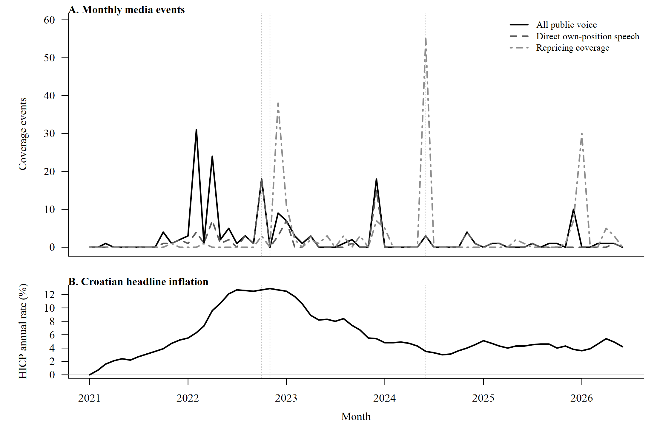
Monthly public voice, direct own-position speech and repricing coverage
Source: authors’ calculations. The upper panel reports monthly coverage events; the lower panel reports the Croatian headline HICP annual rate. The event register is not an official fee index, and the 2026 series ends in June.
Information about the relevant economic object was therefore present in public sector speech before repricing coverage became concentrated. This finding is narrower than a claim about organisational knowledge. It cannot show that every local price setter received the information or that public statements match private expectations.

4.3 Timing and organisational location
Repricing first appears in the refreshed event register in 2021-11. The result is therefore not that fees remained unchanged until 2024. It concerns the concentration of coverage. Overall public voice peaks in 2022-02 and repricing in 2024-06, a gap of 28 months. The repricing peak follows the HICP peak by 19 months.
June 2024 contains 55 repricing events. They account for 29.9 per cent of all repricing coverage and 91.7 per cent of the 2024 repricing material. The same-month chained HICP price level stands 25.7 per cent above June 2021.
Table 9. Where speech and adjustment are located inside the sector.
Institutional unit | Direct own-position speech | All public voice | Repricing | Charitable response | Matched named units
Parish | 14 | 15 | 30 | 2 | 0
Diocese or archdiocese | 40 | 109 | 53 | 0 | 3
Religious order or monastery | 9 | 11 | 1 | 0 | 0
Caritas or relief body | 0 | 2 | 0 | 59 | 0
Bishops’ conference | 19 | 20 | 72 | 0 | 1
Vatican or Pope | 0 | 4 | 3 | 1 | 0
Church, no specific unit | 0 | 1 | 7 | 0 | 0
No church unit acts | 1 | 5 | 18 | 1 | 0
Source: authors’ recoding of all 475 posts: 465 retained three-run majority labels and 10 single-coded addendum labels. Named-unit matches require the same specific unit to speak about its own position before a later repricing report; identifying names remain in the private analysis files. Counts are coverage events, not a census of institutional actions.
Public voice is concentrated in dioceses: they account for 109 public-voice events, 40 direct own-position events and 53 repricing reports. The bishops’ conference accounts for 20 voice events, 19 direct own-position events and 72 repricing reports. Parishes account for 15 voice events and 30 repricing reports. Religious orders account for 11 and 1. Caritas accounts for 59 of the 63 charitable-response posts and no repricing report.
Figure 2. Public voice and repricing coverage by institutional unit.
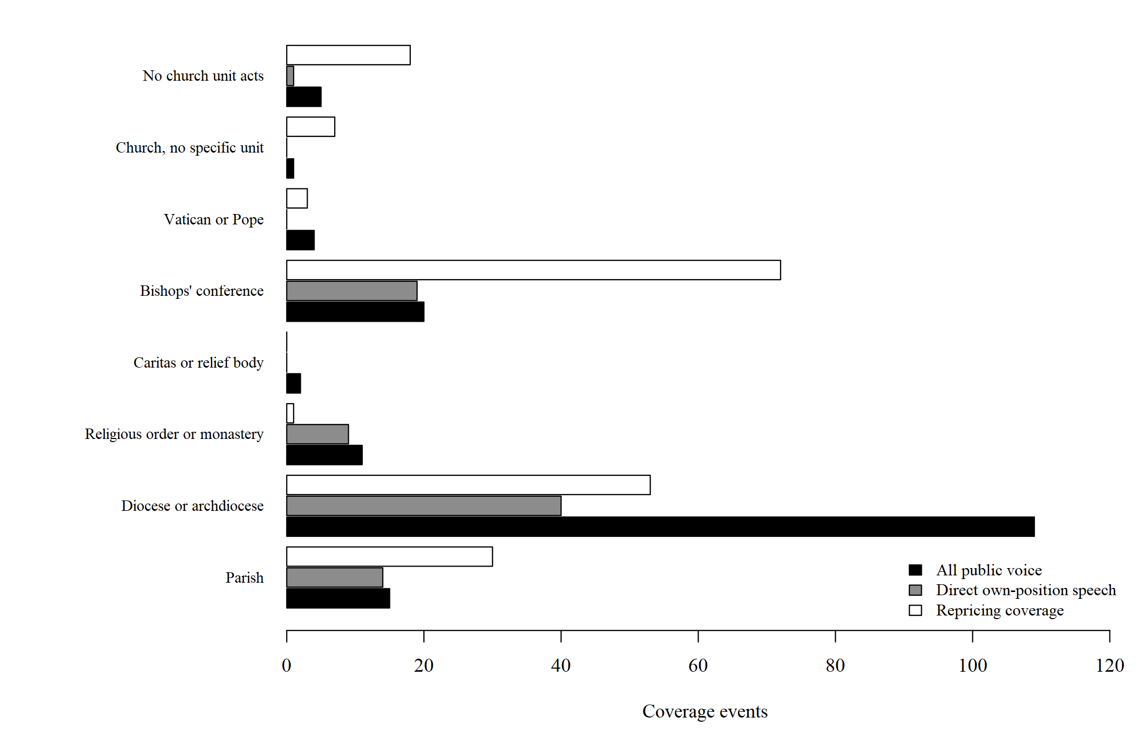
Distribution of public voice and repricing coverage across institutional units
Source: authors’ calculations on the 475-post measured set. Bars are media coverage events, not a census of institutional actions.
At least one relevant event names 29 distinct bodies. Twenty appear in direct own-position speech and 13 in repricing coverage. Four named bodies appear in both, with speech first. Their lags range from 1 to 1 505 days, the median is 669 days, and 3 exceed one year. Three matches are diocesan and one is the bishops’ conference.
The one-day match is effectively contemporaneous. The other three show a within-body ordering that cannot be attributed entirely to different organisational units receiving different information. The small number of matches prevents sector-wide generalisation.

4.4 Does the media indicator follow inflation?
Table 5. Does coverage of the cost of living track actual prices?
Period | Months covered | N | Inflation ranged from | All items | Food | Energy | Above vs below 4%
2021-01 to 2024-06 | 2021-01 to 2024-06 | 37 | 0.0 to 12.9 | 0.48 | 0.44 | 0.24 | 1.96
2024-07 to 2026-06 | 2024-07 to 2026-06 | 24 | 3.0 to 5.4 | 0.15 | -0.31 | 0.32 | 0.69
Source: authors’ calculations; Croatian HICP annual rate of change from Eurostat (prc_hicp_minr, all items, food and non-alcoholic beverages, energy), retrieved 5 August 2026. Figures are correlations between the monthly share of corpus posts mentioning the cost of living and each price series. The last column is mean coverage in months when inflation was at or above 4% divided by mean coverage below it.
The refreshed official database produces a positive but weaker early relationship than the broader accumulator. Across 37 monitoring months, the monthly cost-of-living share correlates 0.48 with headline HICP, 0.44 with food and 0.24 with energy. Headline inflation ranges from 0.0 to 12.9 per cent with a standard deviation of 4.03. Mean attention is 0.28 per cent below four-per-cent inflation and 0.55 per cent at or above it, a ratio of 1.96.
The later backfill window contains only a narrow inflation range, from 3.0 to 5.4 per cent with a standard deviation of 0.60. Its correlations are 0.15 with headline HICP, -0.31 with food and 0.32 with energy. Mean attention falls from 0.32 per cent below the threshold to 0.22 per cent above it, a ratio of 0.69. This period does not validate a stable attention threshold.
Table 6. The same relationship under three different specifications.
Period | Specification | N | Estimate | Standard error | t
2021-01 to 2024-06 | Levels, with standard errors robust to trend and persistence | 37 | 0.0463 | 0.0107 | 4.33
2021-01 to 2024-06 | Month-on-month changes only | 35 | 0.0454 | 0.0993 | 0.46
2021-01 to 2024-06 | Post counts, allowing for how much was collected | 37 | 0.1082 | 0.0272 | 3.98
2024-07 to 2026-06 | Levels, with standard errors robust to trend and persistence | 24 | 0.0377 | 0.0613 | 0.61
2024-07 to 2026-06 | Month-on-month changes only | 23 | 0.0681 | 0.0887 | 0.77
2024-07 to 2026-06 | Post counts, allowing for how much was collected | 24 | 0.1341 | 0.1758 | 0.76
Source: authors’ calculations. The dependent variable is the monthly share of corpus posts mentioning the cost of living, except in the third specification, where it is the monthly count with the log of total posts entered as an offset. Month-on-month changes use consecutive observed months only.
In the early window, the levels estimate remains positive with Newey–West standard errors (t = 4.33), and the count model with a volume offset is similar (t = 3.98). First differences are weak (t = 0.46). The later-window statistics are 0.61, 0.76 and 0.77. The official-corpus evidence therefore supports a medium-run association during the inflation surge, not a mechanical monthly response and not a stable relationship after the surge.

4.5 Charitable and normative responses
Charitable response accounts for 63 posts, or 13.3 per cent, and is concentrated in Caritas and related relief bodies. Claims about who bears the burden account for 13 posts, or 2.7 per cent. Their annual counts are 2, 1, 5, 3, 2 and 0 from 2021 through the first half of 2026.
Relief is therefore more visible than structural diagnosis in the monitored public record. This does not imply that the sector failed to articulate such claims elsewhere. Homilies, pastoral letters and local activity may not enter the database, and register reliability is the weakest coding dimension. The finding is secondary to the timing evidence.
The imbalance nevertheless matters for narrative economics because recurring public stories help organise which causes and remedies become thinkable (Shiller, 2017).

5. Discussion

5.1 What changes with the new database
The official corpus reduces the broad accumulator to a consistently filtered religion-salient database. Cost-of-living mentions fall to 1 486, the candidate pool to 761 and the domestic measured set to 475. The attention–HICP correlation during the main shock is 0.48 rather than the stronger relationship obtained from the broad input. This is a substantive revision: the new analysis gives less support to media attention as a high-fidelity proxy for inflation.
The organisational timing result is more robust. The own-position peak remains 2022-10, repricing remains concentrated in 2024-06, and the 20-month gap remains. The four named-body sequences, the 669-day median and the three lags longer than one year also survive. The central claim should therefore rest on event ordering and within-body matches, not on a strong attention correlation.

5.2 Implications for price adjustment
Public own-position speech makes complete inattention to the relevant object an insufficient aggregate explanation. It does not eliminate partial inattention. Local price-setting units may update at different times, and national or diocesan public speech may not transmit to every parish.
A fixed technical menu cost is also unlikely to explain the entire pattern by itself. By the repricing peak, the comparable HICP price level was 25.7 per cent above its June 2021 level, and the sector had publicly discussed its own economic position for 20 months. Yet menu costs can combine with governance costs and fairness concerns.
The most defensible interpretation is joint. Mission-based relationships can make repricing reputationally costly when household hardship is most salient. Dispersed authority can delay transmission and approval. The event register observes a sequence consistent with both mechanisms but contains no variation that isolates one while holding the other fixed.

5.3 A boundary condition for conventional price data
Most evidence on price duration comes from retail goods and services with regular transaction data (Dhyne et al., 2006; Klenow & Malin, 2010; Nakamura & Steinsson, 2008). Religious services differ through weak competitive pressure, customary rather than indexed prices, and organisationally dispersed decision rights. A long reported adjustment interval does not contradict state-dependent pricing generally; it identifies a setting in which standard incentives may be attenuated.
Croatia’s euro changeover may have provided an occasion to revise fees. Aggregate research finds no robust overall conversion effect and locates effects in selected products (Falagiarda et al., 2023; Sorić, 2024). The observed sequence begins before January 2023 and continues to June 2024, so conversion cannot explain the full interval.
Media event registers can make otherwise invisible stages observable in other sectors without price microdata: clubs, informal providers, small family firms and organisations below reporting thresholds. Their estimand must remain narrow. Coverage records reported events and public statements, not prices, pass-through or adjustment hazards.

5.4 Limitations
Five limitations define the claim. First, public speech may be strategic and does not certify private cognition. Second, newsworthiness affects both whether an event is covered and how often it is repeated. Third, coverage may lag the underlying decision; direct fee schedules are required to measure price duration. Fourth, only four named bodies can be matched across speech and repricing. Fifth, 32 refreshed candidates, including 10 domestic items, are single-coded addenda rather than three-run majorities.
The collection change adds another constraint. Identical inclusion rules make the two eras rule-comparable, not capture-comparable. The monitoring and backfill streams differ in volume and acquisition method, and the 2024 text gap prevents a continuous exposure series. This is why the paper separates stream-specific instrument checks from descriptive event timing.

6. Conclusion
An unchanged price cannot show whether a seller failed to notice a shock or noticed it and delayed action. The new official DigiKat database supplies a public-information channel for Croatia’s religious sector.
The refreshed analysis is both weaker and stronger than the earlier broad-data account. The association between cost-of-living coverage and headline HICP during the main shock is moderate at 0.48 and disappears in first differences. The organisational sequence is stable: household-hardship speech peaks in February 2022, own-position speech in October 2022 and repricing coverage in June 2024. Four named bodies exhibit speech before later repricing coverage, and three lags exceed one year.
Relevant information was publicly present before adjustment coverage became concentrated. This narrows the role of pure inattention but does not identify fairness, governance or menu costs separately. The next empirical step is to recover dated fee schedules from dioceses and parishes. Linking those prices to the event register would distinguish reporting delay from decision delay and permit direct estimates of price duration.

References
Aarab, I., Bańbura, M., Bobeica, E., & Leguay, T. (2025). Tracking inflation attention. ECB Economic Bulletin, 6/2025.
Alvarez, F., Beraja, M., Gonzalez-Rozada, M., & Neumeyer, P. A. (2019). From hyperinflation to stable prices: Argentina’s evidence on menu cost models. Quarterly Journal of Economics, 134(1), 451–505. https://doi.org/10.1093/qje/qjy022
Baker, S. R., Bloom, N., & Davis, S. J. (2016). Measuring economic policy uncertainty. Quarterly Journal of Economics, 131(4), 1593–1636. https://doi.org/10.1093/qje/qjw024
Bils, M., & Klenow, P. J. (2004). Some evidence on the importance of sticky prices. Journal of Political Economy, 112(5), 947–985.
Blinder, A. S., Canetti, E. R. D., Lebow, D. E., & Rudd, J. B. (1998). Asking about prices: A new approach to understanding price stickiness. Russell Sage Foundation.
Coibion, O., Gorodnichenko, Y., & Kumar, S. (2018). How do firms form their expectations? New survey evidence. American Economic Review, 108(9), 2671–2713. https://doi.org/10.1257/aer.20151299
Čižmešija, M., Lolić, I., & Sorić, P. (2017). Disentangling the relationship between news media and consumers’ inflation sentiment: The case of Croatia. Czech Journal of Economics and Finance, 67(3), 221–249.
Dhyne, E., Álvarez, L. J., Le Bihan, H., Veronese, G., Dias, D., Hoffmann, J., Jonker, N., Lünnemann, P., Rumler, F., & Vilmunen, J. (2006). Price changes in the euro area and the United States: Some facts from individual consumer price data. Journal of Economic Perspectives, 20(2), 171–192.
Falagiarda, M., Gartner, C., Mužić, I., & Pufnik, A. (2023, March 7). Has the euro changeover really caused extra inflation in Croatia? ECB Blog.
Gagnon, E. (2009). Price setting during low and high inflation: Evidence from Mexico. Quarterly Journal of Economics, 124(3), 1221–1263. https://doi.org/10.1162/qjec.2009.124.3.1221
Gentzkow, M., Kelly, B., & Taddy, M. (2019). Text as data. Journal of Economic Literature, 57(3), 535–574. https://doi.org/10.1257/jel.20181020
Golosov, M., & Lucas, R. E., Jr. (2007). Menu costs and Phillips curves. Journal of Political Economy, 115(2), 171–199. https://doi.org/10.1086/512625
Grimmer, J., & Stewart, B. M. (2013). Text as data: The promise and pitfalls of automatic content analysis methods for political texts. Political Analysis, 21(3), 267–297. https://doi.org/10.1093/pan/mps028
Hansmann, H. B. (1980). The role of nonprofit enterprise. Yale Law Journal, 89(5), 835–901.
Iannaccone, L. R. (1998). Introduction to the economics of religion. Journal of Economic Literature, 36(3), 1465–1495.
Jackson, W. E. (2014). Does organizational form impact pricing asymmetry? Evidence from nonprofit financial institutions. Southern Economic Journal, 81(2), 506–518. https://doi.org/10.4284/0038-4038-2012.294
Kahneman, D., Knetsch, J. L., & Thaler, R. H. (1986). Fairness as a constraint on profit seeking: Entitlements in the market. American Economic Review, 76(4), 728–741.
Kallunki, V., & Zrinščak, S. (2021). Church and welfare in a changing society. Journal of Contemporary Religion, 36(1), 123–142.
Klenow, P. J., & Malin, B. A. (2010). Microeconomic evidence on price-setting. In B. M. Friedman & M. Woodford (Eds.), Handbook of Monetary Economics (Vol. 3, pp. 231–284). Elsevier.
Korenok, O., Munro, D., & Chen, J. (2026). Inflation and attention thresholds. Review of Economics and Statistics, 108(3), 842–850.
Lamla, M. J., & Maag, T. (2012). The role of media for inflation expectations. Journal of Money, Credit and Banking, 44(7), 1325–1350.
Maćkowiak, B., & Wiederholt, M. (2009). Optimal sticky prices under rational inattention. American Economic Review, 99(3), 769–803. https://doi.org/10.1257/aer.99.3.769
Mankiw, N. G., & Reis, R. (2002). Sticky information versus sticky prices: A proposal to replace the New Keynesian Phillips curve. Quarterly Journal of Economics, 117(4), 1295–1328. https://doi.org/10.1162/003355302320935034
Nakamura, E., & Steinsson, J. (2008). Five facts about prices: A reevaluation of menu cost models. Quarterly Journal of Economics, 123(4), 1415–1464.
Pfäuti, O. (2024). The inflation attention threshold. arXiv:2308.09480.
Reis, R. (2006). Inattentive producers. Review of Economic Studies, 73(3), 793–821.
Shiller, R. J. (2017). Narrative economics. American Economic Review, 107(4), 967–1004. https://doi.org/10.1257/aer.107.4.967
Sims, C. A. (2003). Implications of rational inattention. Journal of Monetary Economics, 50(3), 665–690. https://doi.org/10.1016/S0304-3932(03)00029-1
Sorić, P. (2024). The euro and inflation in Croatia: Much ado about nothing? Public Sector Economics, 48(1), 1–37. https://doi.org/10.3326/pse.48.1.1
Steinberg, R. (2006). Economic theories of nonprofit organizations. In W. W. Powell & R. Steinberg (Eds.), The nonprofit sector: A research handbook (2nd ed., pp. 117–139). Yale University Press.
Stubbs, P., & Zrinščak, S. (2009). Croatian social policy: The legacies of war, state-building and late Europeanisation. Social Policy & Administration, 43(2), 121–135.
van Kersbergen, K., & Manow, P. (Eds.). (2009). Religion, class coalitions, and welfare states. Cambridge University Press.

Appendix A. Reproduction
The study runs from the repository root as a numbered R pipeline. The official corpus is resolved through the project path helper and each annotated item is joined by its stable accumulator-row id. Scripts 01–03 create the 1,486-post tag, 761-candidate pool and 475-post measured set. Scripts 04–07 produce response profiles, HICP checks and the retained 120-item blind reliability audit. Scripts 14–16 migrate the object, voice and unit labels, construct named-body matches and derive event timing. Script 17 generates both figures.
Script 08 with the v2 option generates all nine tables and 154 scalar checks. Script 09 installs the table fragments; Script 10 verifies tables, numbers, abstracts and encoding. Script 11 renders full and blinded Word manuscripts outside the repository. Script 12 creates a disclosure-screened replication package. The end-to-end command is:
Rscript studies/inflation-salience/RUN_ALL.R --v2 --no-network
The corpus itself is not redistributed because it contains licensed media text. Aggregate and label-only outputs carry no URLs, headlines, outlet names or excerpts.

Appendix B. Coding protocol
Coders see the date, outlet type, headline and an excerpt centred on the cost-of-living expression. They do not see prior labels. Four conditional decisions ask whether the price language is literal, whether religion is substantively linked rather than incidentally adjacent, whether the inflation is domestic or foreign, and which register dominates.
For institution-register items, object is own when the economic content concerns institutional heating, energy, wages, maintenance, insurance, repairs, collections, fees, budgets, property or investments. It is household when the content concerns costs borne by families, pensioners, households or the poor. Both requires comparable weight. Voice is sector when a sector actor speaks directly and outside when the organisation is only written about.
Every domestic item receives a unit label. The unit is the body performing the reported economic action: parish, diocese, religious order, Caritas, bishops’ conference, Vatican, church in general or none. A named match requires direct own-position speech to precede repricing coverage for the same conservatively normalised body. Names never leave the private analysis directory.

